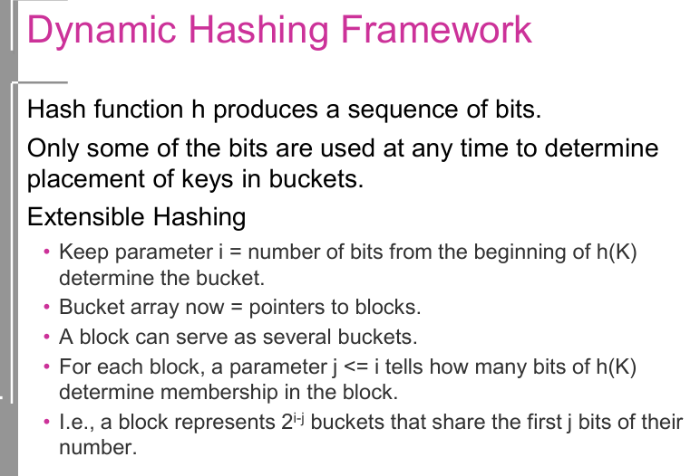

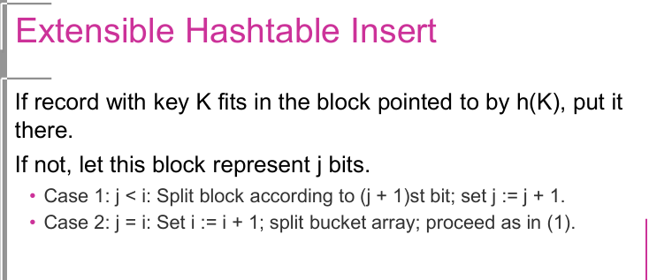

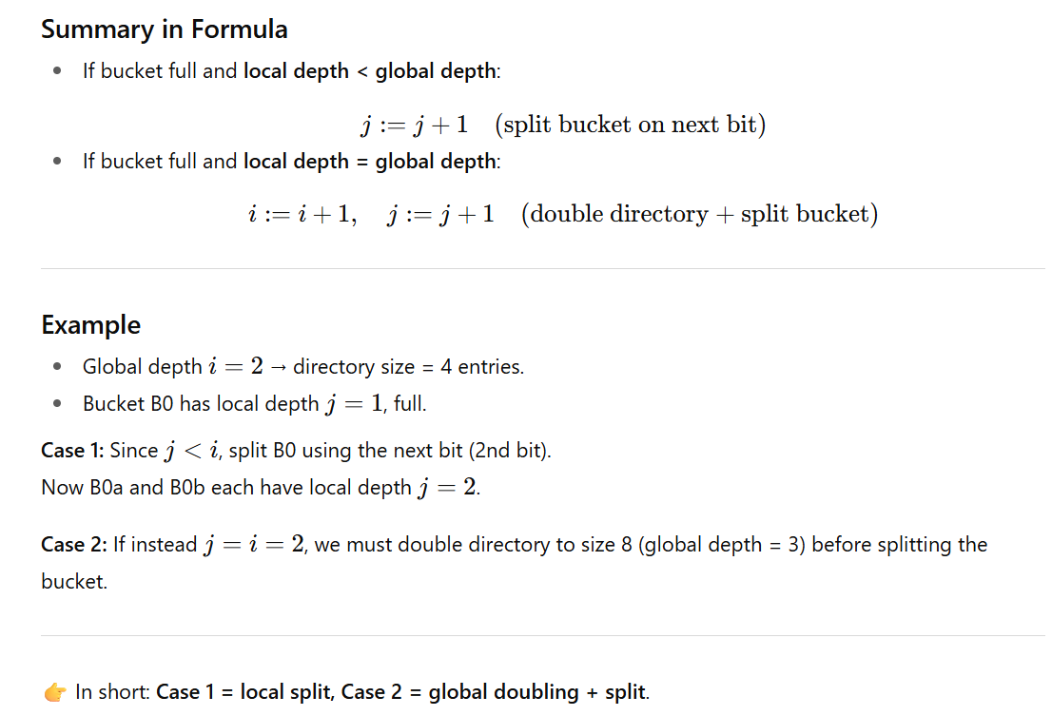
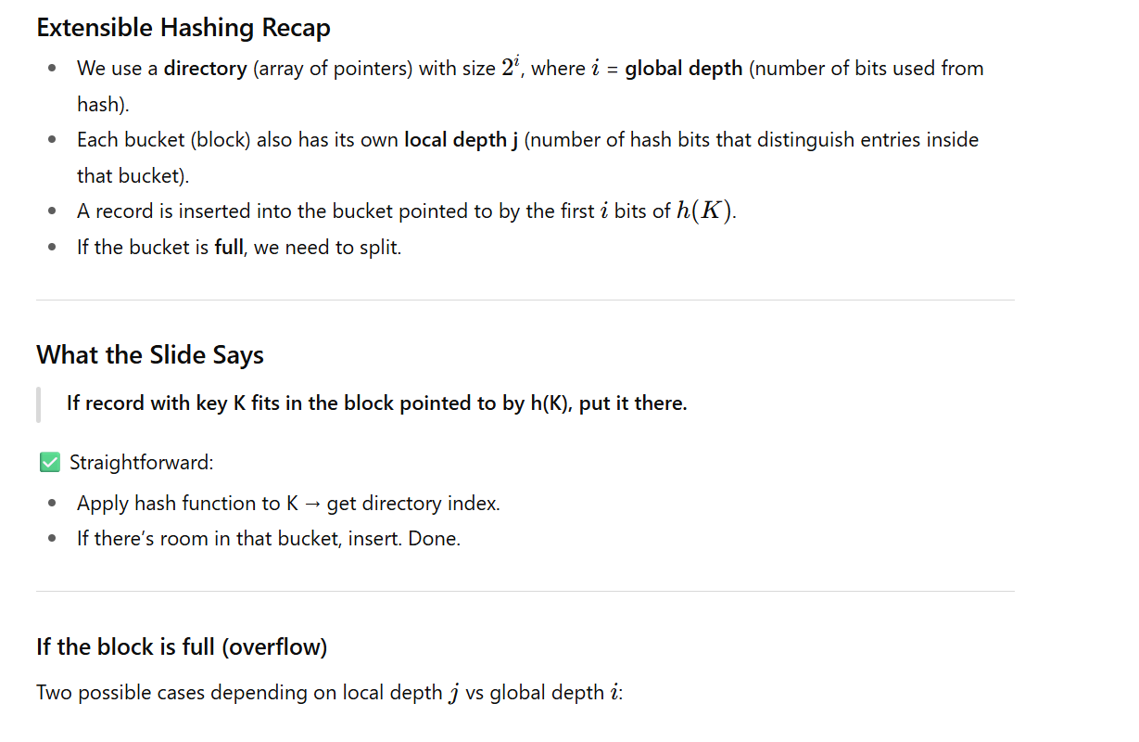
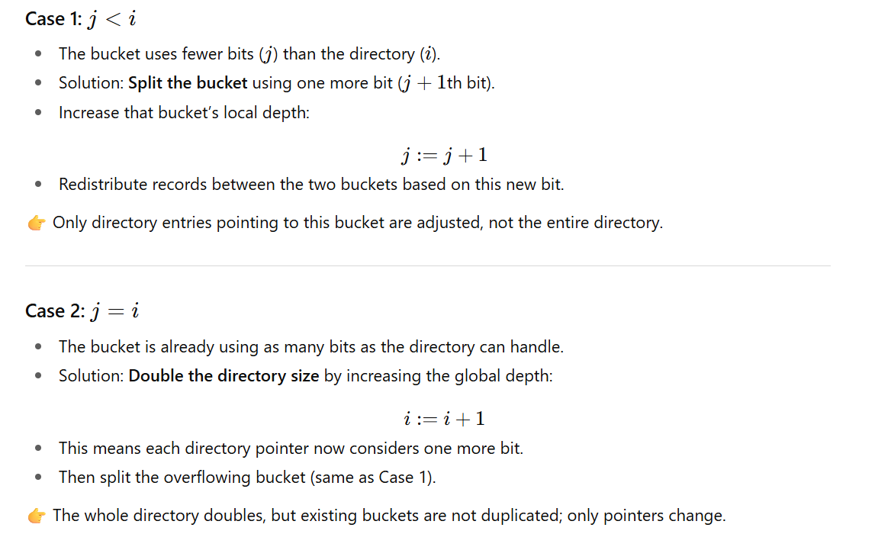

Hashing Technique - Simplified
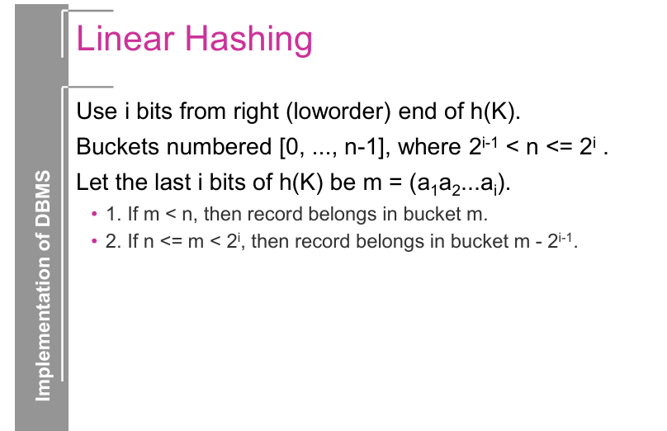
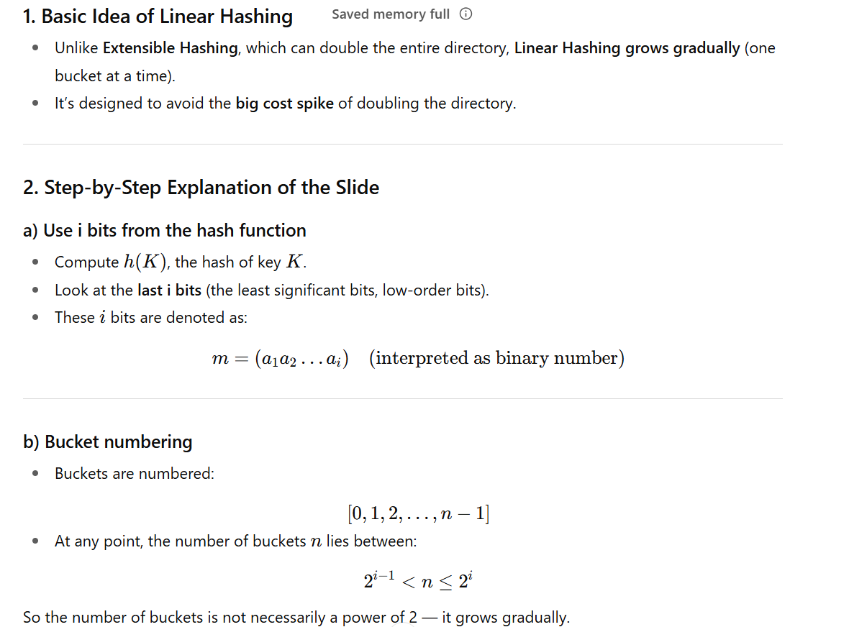

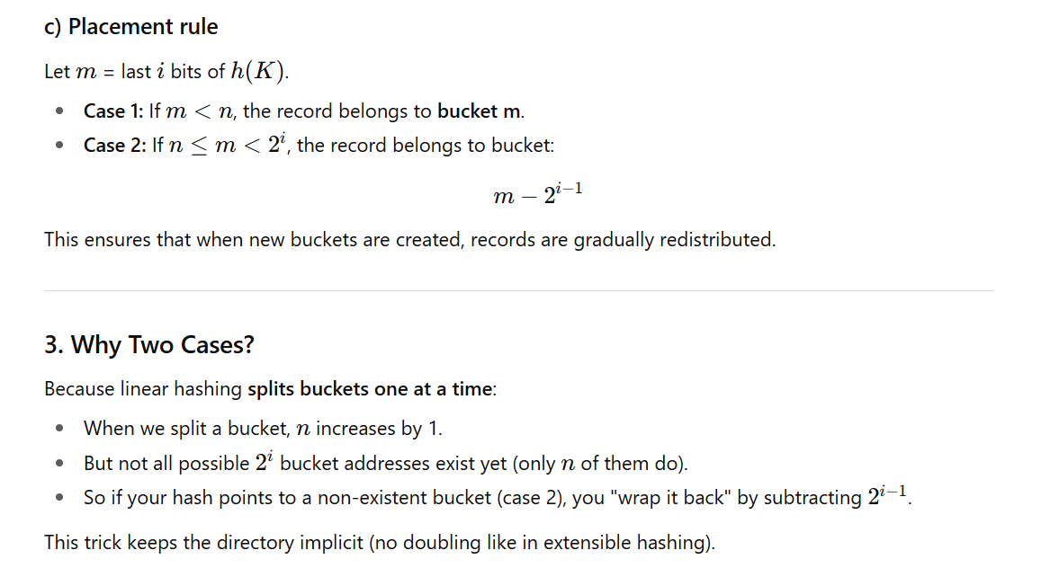
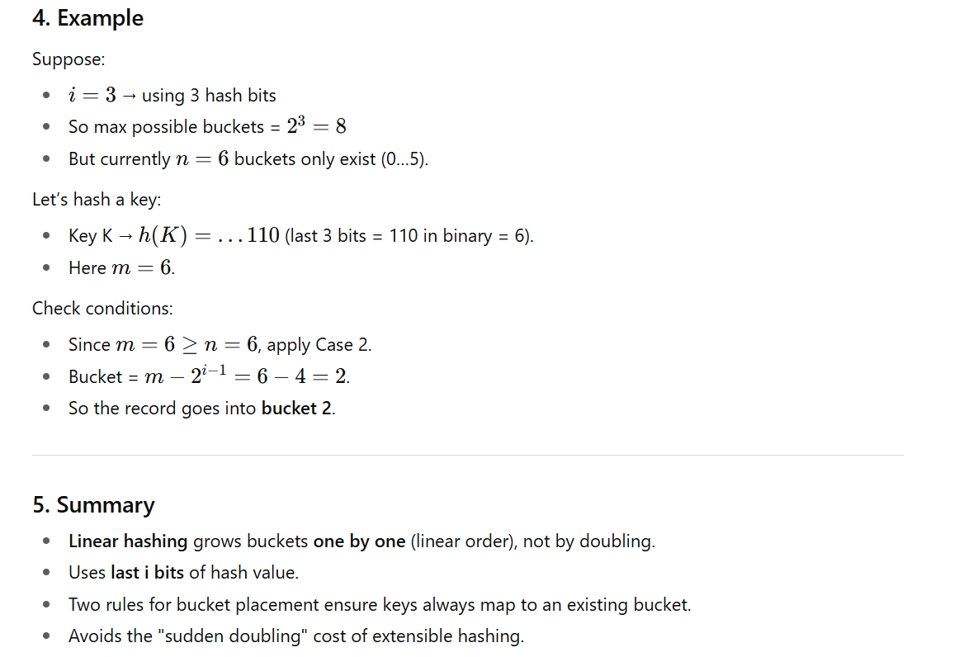
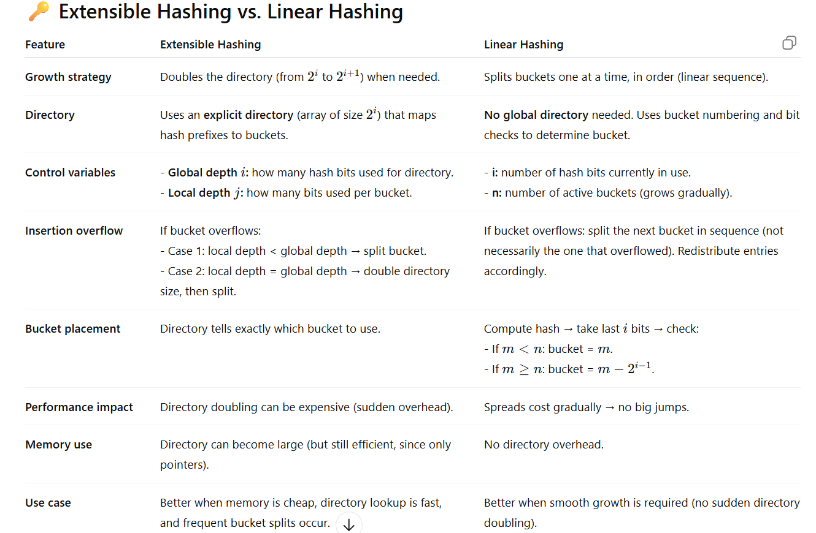

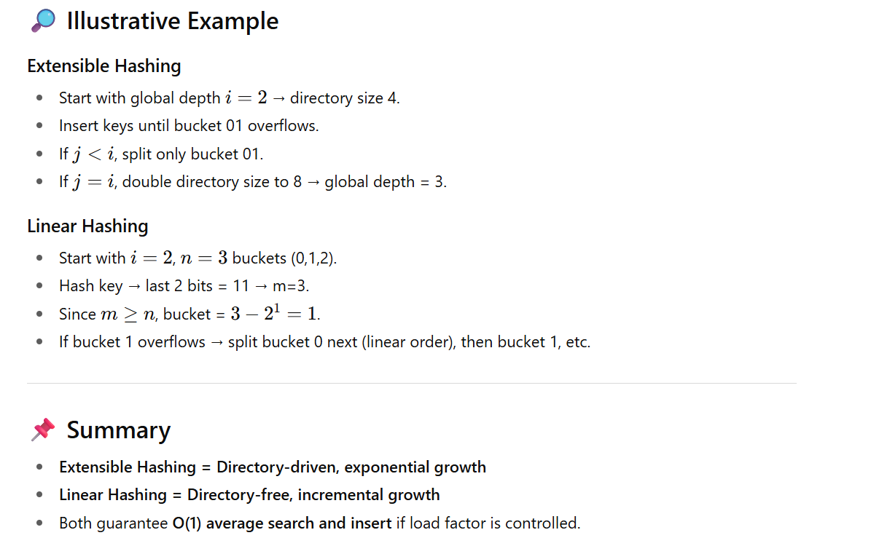

Advantages of Linear Hashing:
- Dynamic Growth:
  - The hash table grows incrementally, avoiding the need for a complete reorganization.
- Efficient Splitting:
  - Only one bucket is split at a time, minimizing the overhead of redistribution.
- Balanced Load:
  - Records are evenly distributed across buckets, reducing the likelihood of hotspots.

Disadvantages of Linear Hashing:
- Complexity:
  - The algorithm is more complex than static hashing methods.
- Overhead:
  - Maintaining the bucket splitting mechanism introduces some overhead.
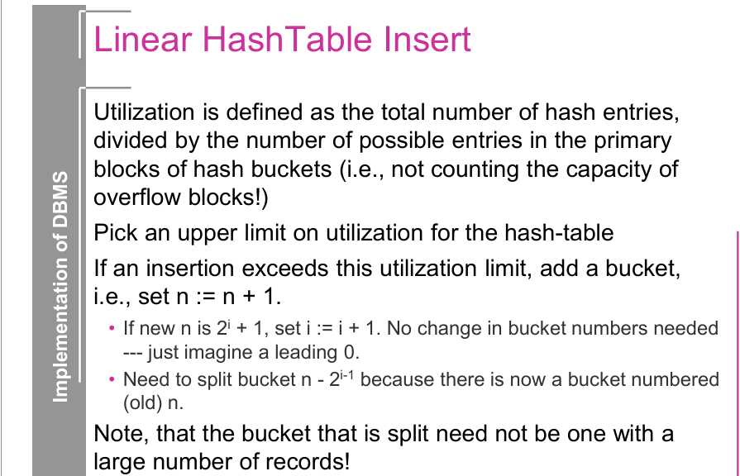

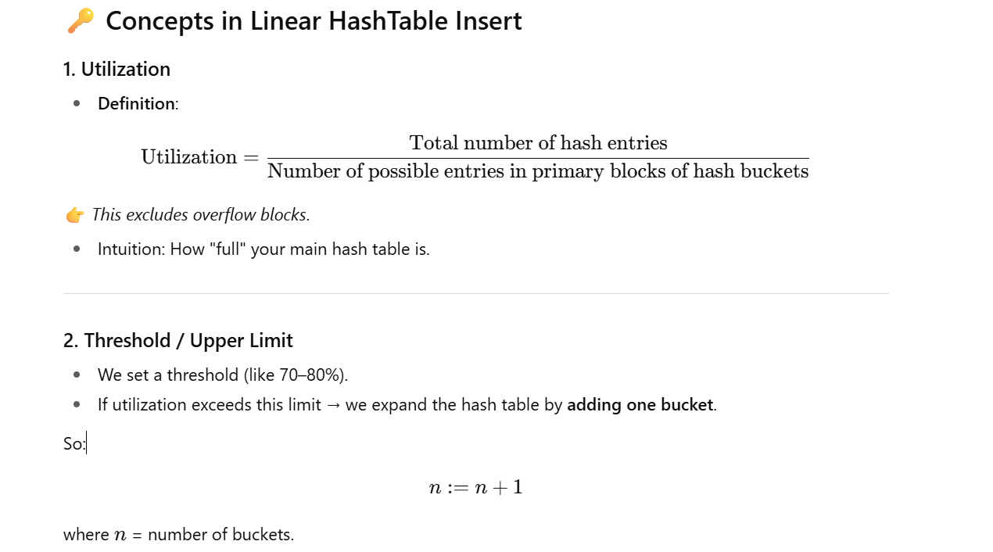

- Numerator = total number of records (entries) stored in the hash table.
- Denominator = maximum number of entries that could fit in all the primary buckets (ignoring overflow).

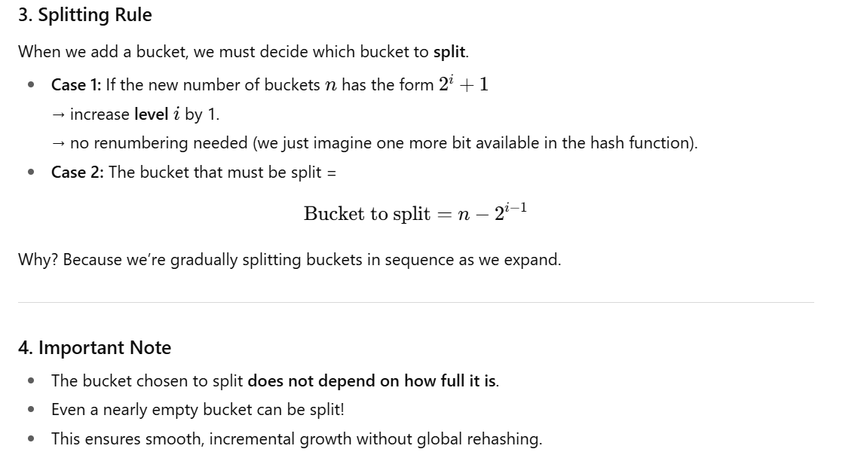
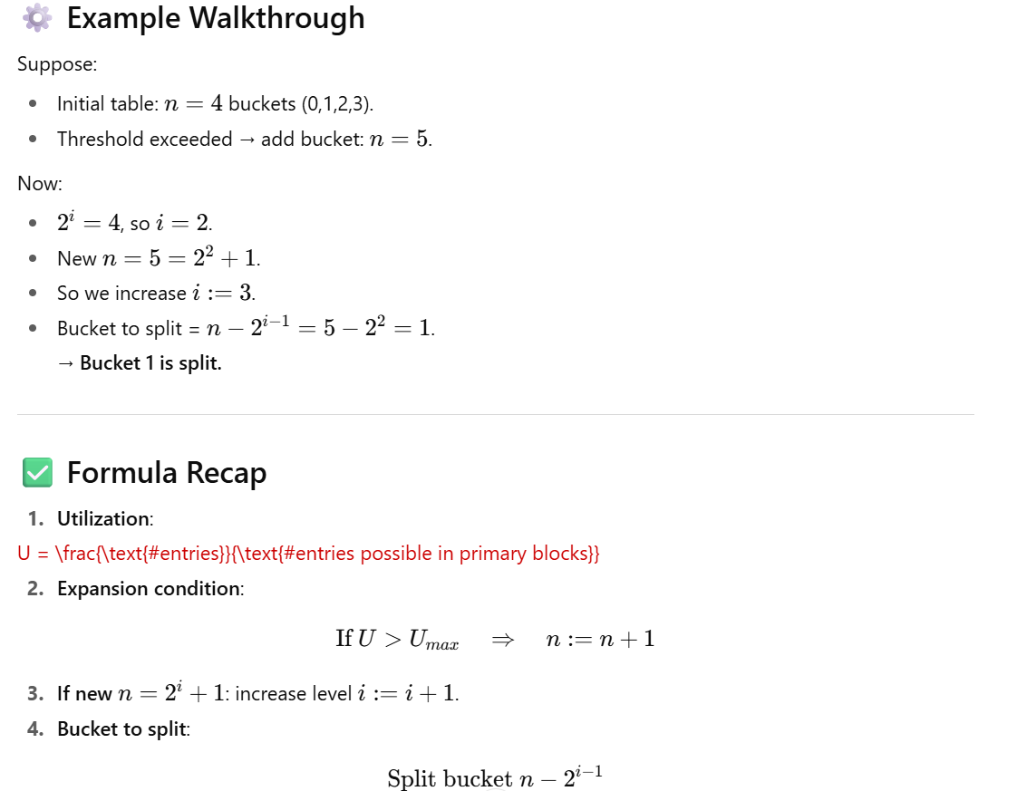
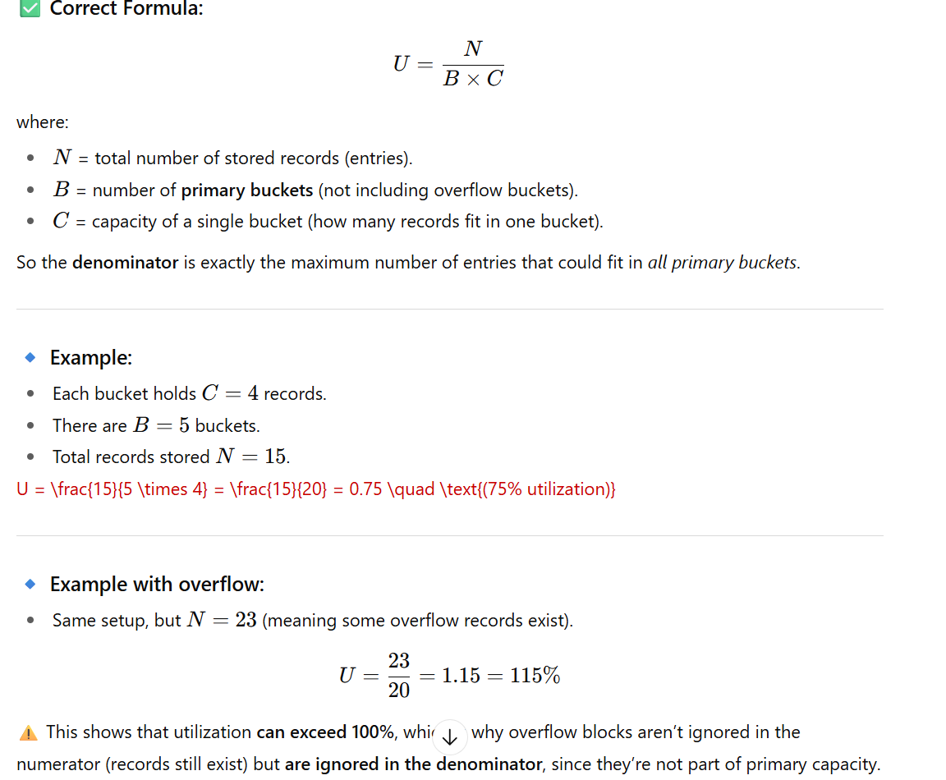

here covers Hashing in DBMS, focusing on basic hashing, extensible hashing, and linear hashing.

1. What is Hashing in DBMS?
- A hash function maps a search key K to a bucket number:
h(K)∈[0,B−1]
- A bucket = a block (or set of blocks) on disk.
- If a record exists, it must be in bucket h(K).
👉 This reduces the search space dramatically (from scanning all records → to only one bucket).
👉 If each bucket fits in one block → only 1 disk I/O per lookup.

2. Hash Table Operations
- Lookup: Compute h(K), search bucket h(K).
- Insertion: Place in h(K). If bucket full → create overflow block.
- Deletion: Locate bucket h(K), remove the record.
⚠️ Overflow blocks can slow things down if too many accumulate.

3. Space Utilization
- We want to keep block utilization between 50% and 80%.
- If <50% → wasted space.
- If >80% → too many overflows.
- Performance depends on hash function quality and bucket size.

4. The Problem of Growth
As data grows, fixed buckets lead to:
- More overflow chains → slower lookups.
- Need for dynamic hashing to adapt:
  - Extensible Hashing
  - Linear Hashing

5. Extensible Hashing

Idea:
- Hash function produces a bit string.
- We use the first ii bits to pick the bucket.
- Maintain a directory: an array of size 2^i, storing pointers to buckets.

Parameters:
- i: global depth = number of bits from hash used in directory.
- j: local depth of a bucket = how many bits decide membership in that bucket.

Insertion Algorithm:
- If bucket not full → insert.
- If full:
  - Case 1: j < i: split bucket using (j+1)-th bit, set j := j+1.
  - Case 2: j = i: double directory (i := i+1), then split.
👉 Recursive splitting possible if records still collide after split.

Pros & Cons:
✅ Handles growth without overflow blocks.
✅ Better space utilization.
❌ Directory doubles occasionally (but manageable if cached in memory).

6. Linear Hashing

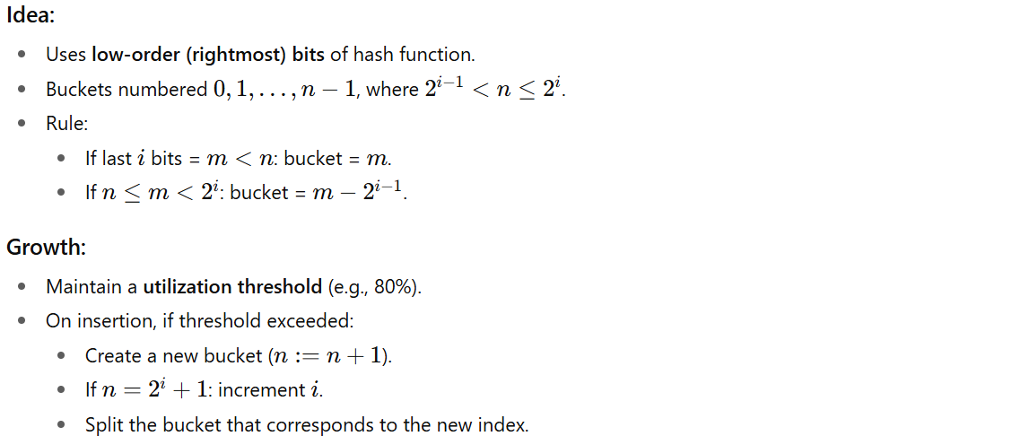
👉 Splits happen gradually, one bucket at a time (linear growth).

Pros & Cons:
✅ No global directory → no indirection.
✅ Smooth growth.
❌ Can still have overflow chains.
❌ Splitting a bucket may not always reduce its load.

7. Comparison
Feature | Extensible Hashing | Linear Hashing
Bits used | Leftmost (MSB) | Rightmost (LSB)
Growth | Directory doubles | Buckets added one at a time
Overflow blocks | None (splits immediately) | Possible
Lookup cost | ≤ 2 I/Os (due to directory) | Depends on overflow chains
Space utilization | Good (no overflows) | Can degrade if skewed

8. When to Use
- Hashing is best for equality queries:
- SELECT * FROM R WHERE R.A = 5;
- B-Trees (or classical indexes) are better for range queries:
- SELECT * FROM R WHERE R.A > 5;

